Migrate a PC from on-premises AD to Azure AD

Stage I
- Open PowerShell as an administrator and run the following commands
  - Set-ExecutionPolicy -ExecutionPolicy Unrestricted
  - Install-Script Upload-WindowsAutopilotDeviceInfo
  - Upload-WindowsAutopilotDeviceInfo -TenantName XXXXX.OnMicrosoft.com
    - Authenticate with the Imperitiv admin account for the client tenant
    - Ensure successful execution of the command
- Reboot the computer
  - On reboot, enter the BIOS and ensure Secure Boot is enabled and the compute has a TPM, and it’s enabled.

Stage II
- Have the user being migrated login
- Ensure Desktop, Documents and Pictures folders are being synced with OneDrive (for the tenant the computer is being migrated to) and the Backup option is on and successful for all three folders
- Have the user review their Downloads folder for anything they need
- Verify browser bookmarks (Chrome/Firefox/Edge, etc.) are exported and saved off to OneDrive and synchronized
- PST files
  - Check Outlook for any attached PST files
  - Verify size and that it will fit in O365
  - Migrate any PST data to their O365 mailbox
  - If the PST data is too large to move within the hour allotted for the users migration:
    - Record the path to the PST
    - Detach the PST from the Outlook profile
    - Close Outlook
    - Move the PST to somewhere such as C:\Outlook Files\
    - After the migration, move the PST back to the users Profile (C:\User\%USERNAME%) and reattach it to Outlook.
    - Set a time to help the user migrate the data from the PST file(s) to the EOL Mailbox
- Open Device Manager and ensure there are no issues with drivers

Stage III
- Create a local computer user in “Computer Management” such as imp-admin and make it a member of the local Administrators group.
- Logout the current user and login as imp-admin
- Disjoin the computer from the on-premises AD domain and reboot the computer
- Login as imp-admin after the reboot and join the computer to Azure Active Directory as the users account using the steps below
- Join the PC to the Azure AD Domain
  - Go to “Settings”, the “Accounts”, then to “Access Work or School”
  - Click on “Connect”

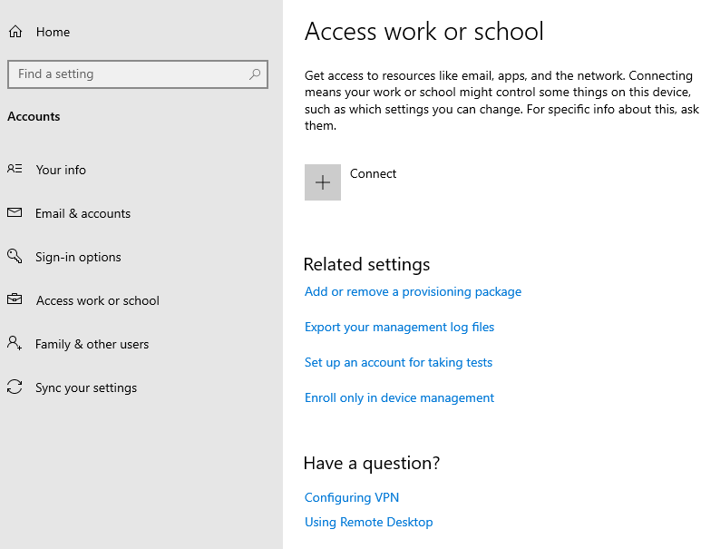

  - Click on “Join this device to Azure Active Directory”
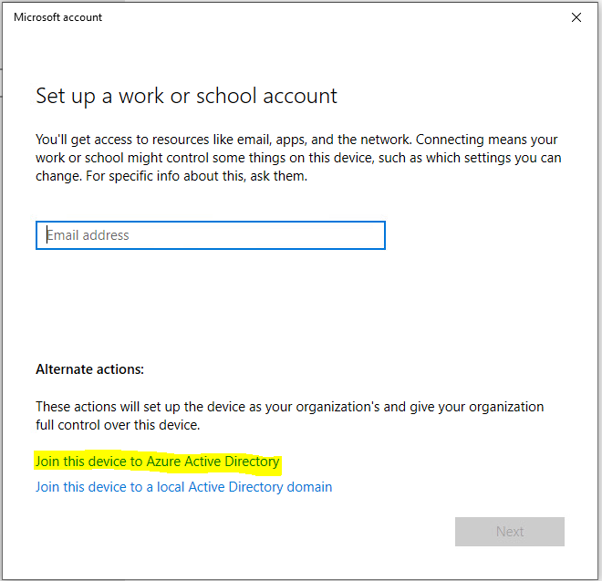

  - Have the user enter their email address (user id) for the new tenant
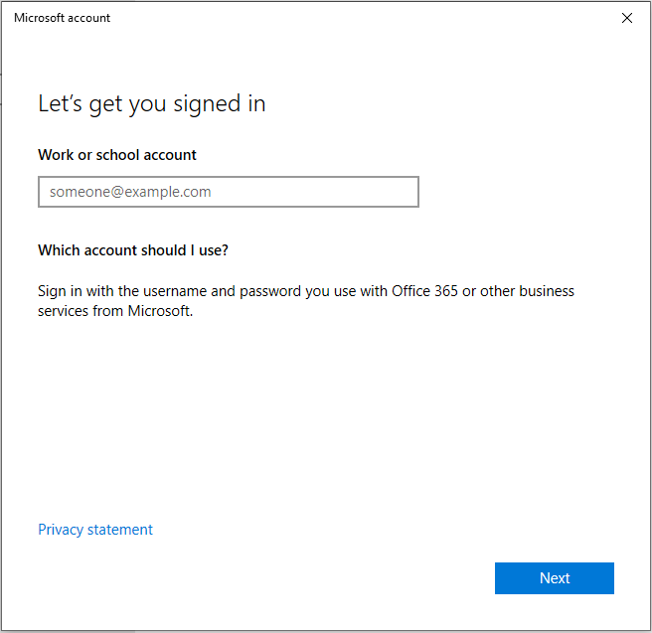

  - Have them enter their password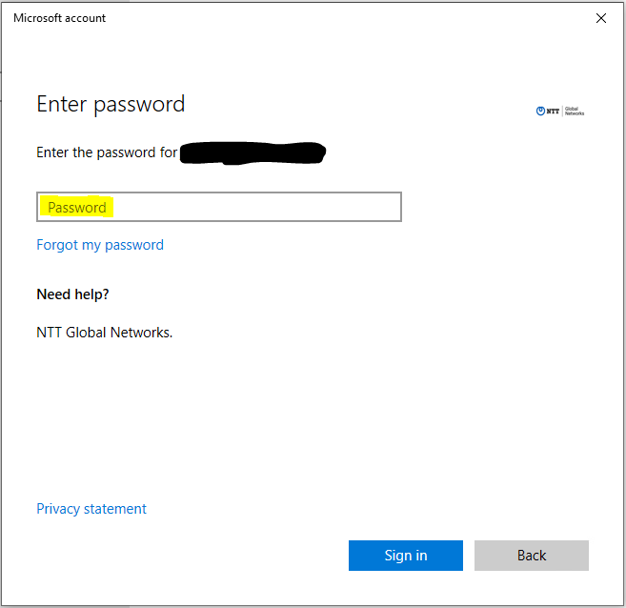

  - Click Next
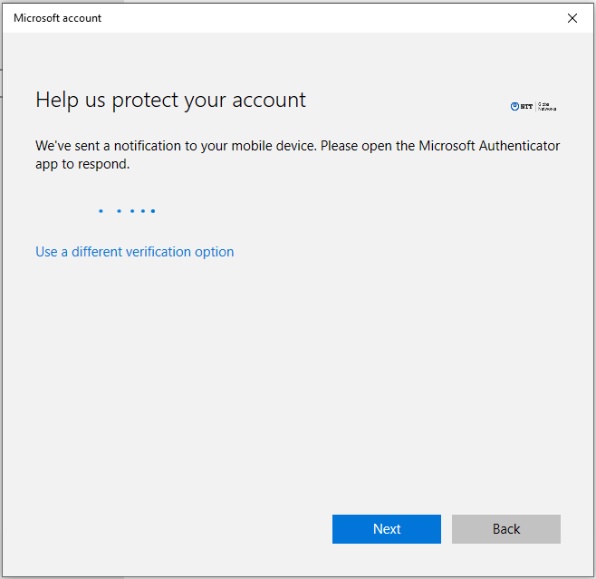

  - Click “Join”
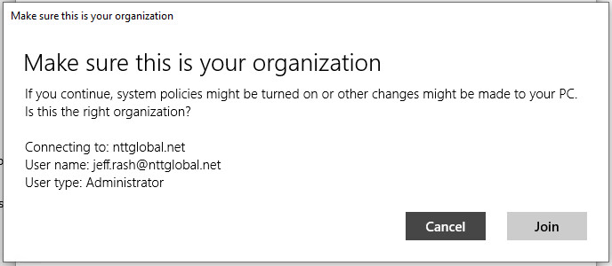

  - Click Done and then reboot the computer
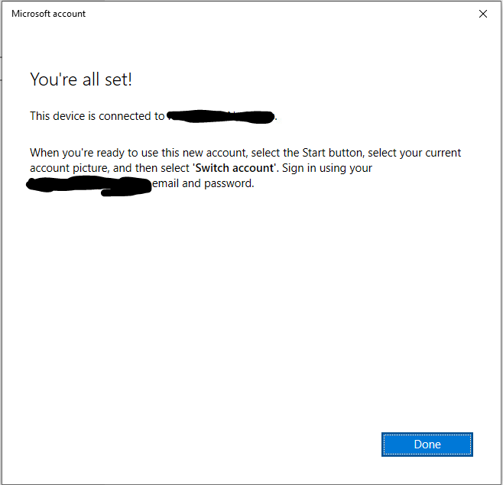

Stage IV
- Login to the machine as their Azure AD account %USERNAME%@DomainName.com
- It will show the “Setting up your device” window. This could take a few minutes to run though. If the first two section do not show “Completed”, then the machine didn’t take the Disable ESP Configuration policy and you’ll need to force reboots and policy updates until it does. It’ll stay stuck on this screen if the first two don’t come up as “Completed” as shown.
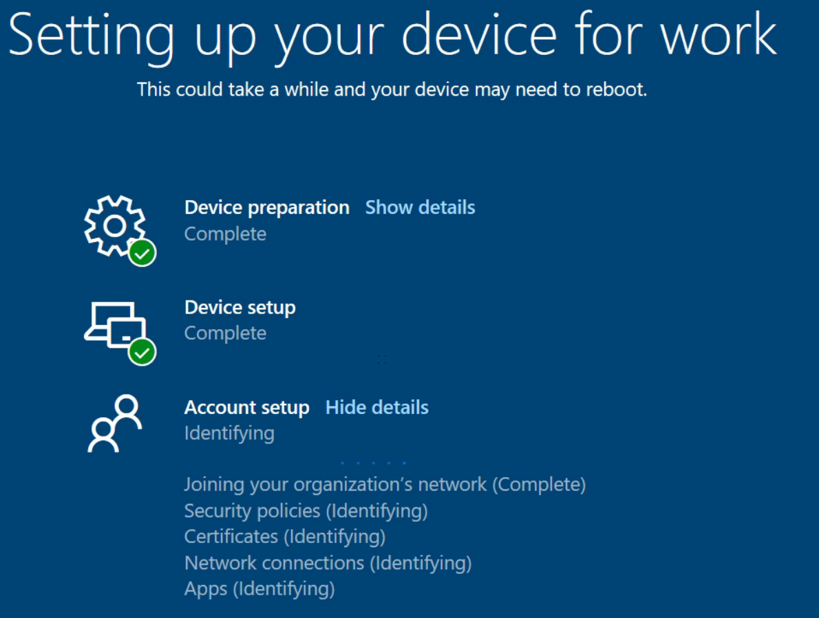
- The user should be logged in successfully and if Windows Hello is enabled, it should have the user set a PIN and possibly allow other biometrics if a finger print reader is available or a camera that meets Hello’s requirements is installed.

Stage V
- Testing
  - After the user logs in to the laptop as their @DomainName.com account:
    - Let the machine sit for 5-6 minutes and wait for OneDrive to setup and start syncing automatically.
    - Ensure OneDrive sets up and syncs
      - Select “Always keep on this device”
    - Setup and verify email access
    - Import bookmarks
    - If any, move any Downloads data retained in step 2 of Stage I.
- Cleanup
  - Ensure user is not an administrator
  - Delete C:\Temp (if you created it) or any other temp folders
  - Rename Azure AD computer object and force a reboot (CompanyCode-SerialNumber)
  - Have the users log back in and verify SharePoint Document Libraries mapped
  - Open “Computer Management” as an Admin and disable the users local account so they can’t switch back to it accidentally, but don’t delete it.

NOTES/Troubleshooting:
https://jocha.se/blog/tech/azure-ad-mdm-intune-error-8018000a
Error 8018000a: “Something went wrong. The device is already enrolled. You can contact your system administrator with the error code 8018000a.
To troubleshoot this issue I used process monitor and found what Windows does when we try to join Azure AD.
After some testing it showed that if we remove the traces from “ongoing Azure AD join” the wizard will continue and succeed.
You can do this by deleting all GUIDs under HKEY_LOCAL_MACHINE\SOFTWARE\Microsoft\Enrollments
Make sure to NOT delete Context, Ownership, Status and ValidNodePaths.
